01. Basic

- The following shows how to calculate the size (the number of nodes) of a binary tree.

int size(Node *node)
{
if (node == NULL)
{
return 0;
}

return size(node->left) + size(node->right) + 1;
}

- The following shows how to calculate the sum of a binary tree.

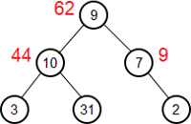

int get_sum(Node *node)
{
if (node == null)
{
return 0;
}

return get_sum(node->left) + get_sum(node->right) + node->data;
}

- The height of a node is the number of edges on the longest path from the node to a leaf. A leaf will have a height of 0. The height of a tree is the height of its root node.

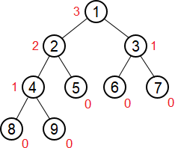

The following shows how to calculate the height of a binary tree.

int height(Node *node)
{
if (node == NULL)
{
return -1;
}

return max(height(node->left), height(node->right)) + 1;
}

- The depth of a node is the number of edges from the root to the node. A root will have a depth of 0. The level of a node is the depth of the node plus 1.

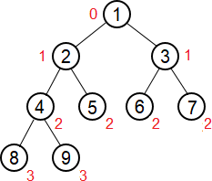

The following shows how to print the depth and level of each node of a binary tree.

void print_depth(Node *node, int depth = 0)
{
if (node == NULL)
{
return;
}

printf("%d: %d\n", node->data, depth);

print_depth(node->left, depth + 1);
print_depth(node->right, depth + 1);
}

int main()
{
…
print_depth(root, 0); // print the depth of each node
print_depth(root, 1); // print the level of each node
}

- The minimum depth of a tree is the number of nodes along the shortest path from root down to the nearest leaf. The following shows how to find the minimum depth of a binary tree.

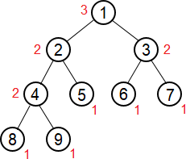

int min_depth(Node *node)
{
if (node == NULL)
{
return 0;
}

return min(min_depth(node->left), min_depth(node->right)) + 1;
}

- The following shows how to print the nodes on a given level of a binary tree.

void print_level(Node *node, int level = 1)
{
if (node == NULL)
{
return;
}

if (level == 1)
{
printf("%d ", node->data);
return;
}

print_level(node->left, level - 1);
print_level(node->right, level - 1);
}

- The following shows how to print the i-th node on a given level.

void print_level(Node *node, int level, int &i)
{
if (node == NULL)
{
return;
}

if (level == 1)
{
--i;
if (i == 0)
{
printf("%d", node->data);
}

return;
}

print_level(node->left, level – 1, i);
print_level(node->right, level – 1, i);
}

- The following shows how to travel a binary tree in level order. It is also called Breadth First Traversal (BFT).

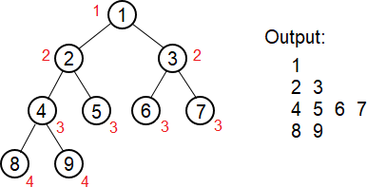

void print_tree(Node *root)
{
int h = height(root);

for (int i = 1; i <= h + 1; i++)
{
print_level(root, i);
printf("\n");
}
}

The following shows another solution.

void levelOrder(Node *root)
{
queue<Node*> q;
q.push(root);

while (!q.empty())
{
Node *n = q.front();
q.pop();
printf("%d ", n->data);

if (n->left != NULL)
{
q.push(n->left);
}

if (n->right != NULL)
{
q.push(n->right);
}
}
}

The following shows how to print the nodes on different lines based on the level.

void levelOrder(Node *root)
{
queue<Node*> q;
q.push(root);

while (!q.empty())
{
int len = q.size();
for (int i = 0; i < len; ++i)
{
Node *n = q.front();
q.pop();
printf("%d ", n->data);

if (n->left != NULL)
{
q.push(n->left);
}

if (n->right != NULL)
{
q.push(n->right);
}
}

printf("\n");
}
}

The following shows another solution.

void levelOrder(Node *root)
{
queue<Node*> q;
q.push(root);
q.push(NULL);

while (!q.empty())
{
Node *n = q.front();
q.pop();

if (n != NULL)
{
printf("%d ", n->data);

if (n->left != NULL)
{
q.push(n->left);
}

if (n->right != NULL)
{
q.push(n->right);
}
}
else if (!q.empty())
{
printf("\n");
q.push(NULL);
}
}
}

- Given a binary tree, first print all leaf nodes, then remove all the leaf nodes from the tree and now print all the new formed leaf nodes and keep doing this until all the nodes are removed from the tree.

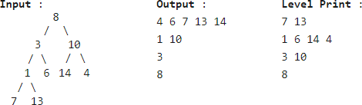

map<int, vector<int>> m;

int height(Node *node)
{
if (node == NULL)
{
return 0;
}

int h = max(height(node->left), height(node->right)) + 1;
m[h].push_back(node->data);

return h;
}

int main()
{
…
height(root);

for (auto p : m)
{
for (int data : p.second)
{
printf("%d ", data);
}

printf("\n");
}
}

- Find a node in a binary tree.

Node *find(Node *node, int x)
{
if (node == NULL)
{
return NULL;
}

if (node->data == x)
{
return node;
}

Node *ret = find(node->left, x);
if (ret == NULL)
{
ret = find(node->right, x);
}

return ret;
}

- Find the distance from a node to the root, that is, the level of the node.

int findLevel(Node *node, int x, int level = 1)
{
if (node == NULL)
{
return 0;
}

if (node->data == x)
{
return level;
}

int ret = findLevel(node->left, x, level + 1);
if (ret == 0)
{
ret = findLevel(node->right, x, level + 1);
}

return ret;
}

- Find the height of a node.

int get_height(Node *node, int x, int &height)
{
if (node == NULL)
{
return -1;
}

int h = max(get_height(node->left, x, height), get_height(node->right, x, height)) + 1;

if (node->data == x)
{
height = h;
}

return h;
}

If you want to get better performance.

int get_height(Node *node, int x, int &height)
{
if (root == NULL)
{
return -1;
}

int lc = get_height(root->left, x, height);
if (height != -1)
{
return height;
}

int rc = get_height(root->right, x, height);
if (height != -1)
{
return height;
}

int h = max(lc, rc) + 1;
if (root->data == x)
{
height = h;
}

return h;
}

- Print the nodes on the path from a node to the root. If you want to print the nodes on the path from the root to a node, you can use a stack or vector.

Node *print_path(Node *node, int x)
{
if (node == NULL)
{
return NULL;
}

if (node->data == x)
{
printf("%d ", node->data);
return node;
}

Node *n = print_path(node->left, x);
if (n == NULL)
{
n = print_path(node->right, x);
}

if (n != NULL)
{
printf("%d ", node->data);
return n;
}

return NULL;
}

- Find the k-th ancestor of a node in binary tree.

Node *findKAncestor(Node *root, int x, int &k, Node **target)
{
if (root == NULL)
{
return NULL;
}

if (root->data == x)
{
if (k == 0)
{
*target = root;
}

return root;
}

Node *n = findKAncestor(root->left, x, k, target);
if (n == NULL)
{
n = findKAncestor(root->right, x, k, target);
}

if (n != NULL && k > 0)
{
--k;
if (k == 0)
{
*target = root;
}
}

return n;
}

- Given a binary tree (not BST), find the node with the maximum/minimum value in the tree.

Node* findMax(Node* node)
{
if (node == NULL)
{
return NULL;
}

Node* lc = findMax(node->left);
Node* rc = findMax(node->right);

if (lc != NULL && lc->data > node->data)
{
node = lc;
}

if (rc != NULL && rc->data > node->data)
{
node = rc;
}

return node;
}

- The following shows how to determine if two binary trees are identical.

bool identical(Node *a, Node *b)
{
if (a == NULL && b == NULL)
{
return true;
}

if (a == NULL || b == NULL)
{
return false;
}

return a->data == b->data &&
identical(a->left, b->left) &&
identical(a->right, b->right);
}

- The following shows how to check if a binary tree B is the subtree of another binary tree A.

bool is_subtree(Node *a, Node *b)
{
if (b == NULL)
{
return true;
}

if (a == NULL)
{
return false;
}

if (identical(a, b))
{
return true;
}

return is_subtree(a->left, b) || is_subtree(a->right, b);
}

- The following shows how to convert a binary tree into its mirror tree. The mirror of a binary tree is another binary tree with left and right children of all non-leaf nodes interchanged.

void mirror(Node* node)
{
if (node == NULL)
{
return;
}

mirror(node->left);
mirror(node->right);

Node* temp = node->left;
node->left = node->right;
node->right = temp;
}

- Given a binary tree, find the mirror of a given node.

int findUtil(Node *a, Node *b, int x)
{
if (a == NULL || b == NULL)
{
return -1;
}

if (a->data == x)
{
return b->data;
}

if (b->data == x)
{
return a->data;
}

int val = findUtil(a->left, b->right, x);
if (val == -1)
{
val = findUtil(a->right, b->left, x);
}

return val;
}

int findMirror(Node *root, int x)
{
if (root == NULL)
{
return -1;
}

if (root->data == x)
{
return root->data;
}

return findUtil(root->left, root->right, x);
}

- Given a binary tree, find if it can be folded or not. A tree can be folded if the left and right subtrees of the tree are structure wise mirror image of each other. In the following, the first tree can be folded, but the second cannot.

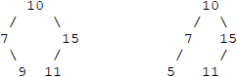

bool symmetric(node* a, node *b)
{
if (a == NULL && b == NULL)
{
return true;
}

if (a == NULL || b == NULL)
{
return false;
}

return symmetric(a->left, b->right) && symmetric(a->right, b->left);
}

bool foldable(node* root)
{
if (root == NULL)
{
return true;
}

return symmetric(root->left, root->right);
}

- Lowest Common Ancestor. Given two nodes, find their Lowest Common Ancestor in a binary tree (not BST).

Node *findLCA(Node* node, int a, int b)
{
if (node == NULL)
{
return NULL;
}

if (node->data == a || node->data == b)
{
return node;
}

Node *left = findLCA(node->left, a, b);
Node *right = findLCA(node->right, a, b);

if (left != NULL && right != NULL)
{
return node;
}

return (left != NULL)? left: right;
}

- The following shows how to find the Lowest Common Ancestor of two nodes in a BST.

Node* findLCA(Node* node, int a, int b)
{
if (node == NULL)
{
return NULL;
}

if (node->data > a && node->data > b)
{
return findLCA(node->left, a, b);
}

if (node->data < a && node->data < b)
{
return findLCA(node->right, a, b);
}

return node;
}

- Find the distance between two nodes of a binary tree.

int findDistance(Node *root, int a, int b)
{
Node *lca = findLCA(root, a, b);

int d1 = findLevel(lca, a, 1);
int d2 = findLevel(lca, b, 1);

return d1 + d2 - 2;
}

- Given a binary tree and a node x, find the shortest distance from a leaf to x.

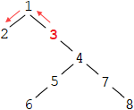

int minHeight(Node *root)
{
if (root == NULL)
{
return INT_MAX;
}

if (root->left == NULL && root->right == NULL)
{
return 0;
}

return min(minHeight(root->left), minHeight(root->right)) + 1;
}

int minDistance(Node *root, Node *x, int parent = INT_MAX)
{
if (root == NULL)
{
return -1;
}

int minx = minHeight(root);
if (parent != INT_MAX)
{
minx = min(minx, parent + 1);
}

if (root == x)
{
return minx;
}

int d = minDistance(root->left, x, minx);
if (d == -1)
{
d = minDistance(root->right, x, minx);
}

return d;
}

